The wisdom of the crowd: why it is more important than ever to focus on innovation

At the opening of the 105th edition of the Riva fairs, futurist Alberto Mattiello described the fair as an amplifier of collective intelligence. The challenge: using AI and data to anticipate market trends, new technologies to manage the transition towards sustainability and traceability, and start-ups as a compass pointing towards new paths.

In 1906, at a livestock fair in Plymouth, 787 people estimated the weight of an ox. The scientist Francis Galton discovered that the mathematical average of all the guesses was almost identical to the animal’s actual weight, proving to be more accurate than any single estimate by experts or butchers.
This is the theory of the wisdom of crowds. It explains well why international trade fairs such as Expo Riva Schuh and Gardabags still make a great deal of sense. In a global supply chain such as the footwear and bag industry, no single entity possesses a complete view of the market: manufacturers, buyers, retailers, startups and institutions each observe a different aspect of reality. «An international trade fair is not just a meeting place: it is an amplifier of collective intelligence, where diverse and partial insights build a shared vision of the global market», explained Alberto Mattiello, futurist and member of the Scientific Committee of Expo Riva Schuh and Gardabags, as he opened the 105th edition last June.
Hence the focus on innovation. Technology does not replace the experience of industry professionals: it enhances it. AI, data and digital tools help to anticipate demand, analyse stock levels, reduce errors, visualise products and minimise returns through personalised fitting.
The point is not to delegate decisions to machines, but to give manufacturers and retailers better tools to choose, adjust and act before others do.

There is a second theme: shoes and bags will no longer be judged solely on how they look or fit, but also on how they are made — data, supply chain, sustainability and reliability. A fashion system in which sustainability is increasingly becoming the deciding factor and traceability is key to reputation. Once again, innovation and new technologies are central to helping the sector make this momentous leap.
Against this backdrop, the Innovation Village Retail organised by Expo Riva Schuh and Gardabags, featuring the startups exhibiting there, is not merely a side event to the trade fair, but its very radar: it offers a preview of the transformations that will soon become commonplace or even the norm. Here, the startups are the faint signals that help us gauge where the market is heading.
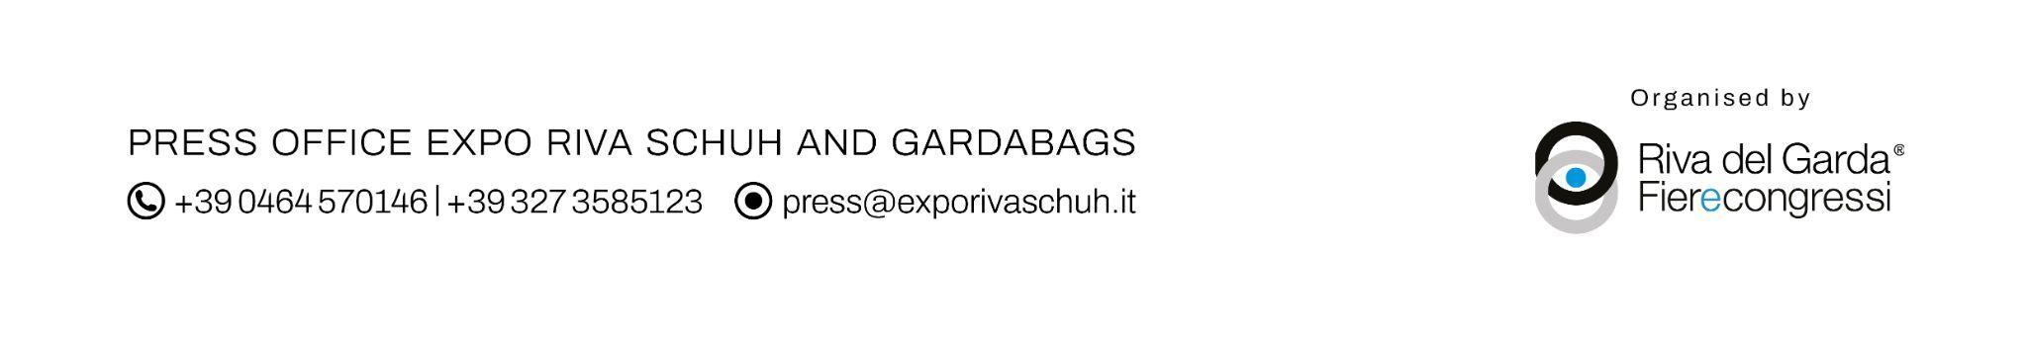
Taken one by one, these insights remain incomplete. It is by bringing them together – thanks to events such as Expo Riva Schuh and Gardabags – that they form a clear path forward.

